CÔNG NGHỆ PHẦN MỀM

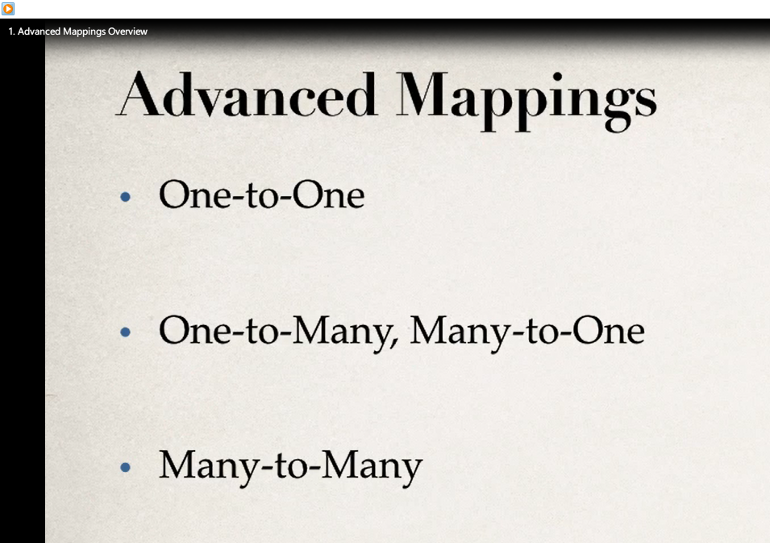

<https://stackjava.com/tu-hoc-hibernate-framework-qua-code-vi-du>

ALTER TABLE nhanvien ADD manv int not null AUTO_INCREMENT PRIMARY KEY FIRST;

Java Hibernate Tutorial Part 11 - One class to Two tables

https://www.youtube.com/watch?v=F3Bct8tkfcs&ab_channel=PatrickWashingtonDC

<https://viblo.asia/p/real-time-emotion-detection-xay-dung-mang-nhan-dien-cam-xuc-khuon-mat-cho-nguoi-moi-bat-dau-vyDZONmQKwj>

<https://www.kaggle.com/gauravsharma99/facial-emotion-recognition>

# Easy way to use multiple Fxml in JavaFX stage | Multiple Fxml loading Tutorial

<https://www.youtube.com/watch?v=5yQbt6lYRqk&t=824s&ab_channel=CoolITHelp>

https://www.youtube.com/watch?v=z4LVoLg6ch0&ab_channel=JaretWright

<https://www.javaer101.com/en/article/36433780.html>

<https://openplanning.net/11079/javafx-tableview>

<https://www.youtube.com/watch?v=Gg0dKC6xLGU&ab_channel=H%C6%B0ngNguy%E1%BB%85n>

[**Desktop-Applications-JavaFX**](https://github.com/AbdelrahmanBayoumi/Desktop-Applications-JavaFX)

<https://github.com/AbdelrahmanBayoumi/Desktop-Applications-JavaFX>